**Practice Questions – Week 4**

Q53) Write a Python program to create a tuple with elements defined by the user.

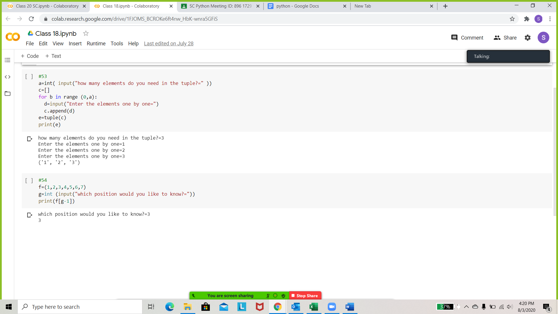

Q54) Write a Python program to find the index of an item of a tuple.

